Introduction to ARM Assembly Language Programming using Raspberry

Jude Rhoa, *Member, IEEE*

[1]

***Abstract*— This lab is a design and implementation of a program intended to allow a user input and count the number of times “LMU” occurs. This code will be run on the Raspberry Pi 3B+. Along with an output message to the terminal, the number of LMU occurrences will be displayed in binary using 3 LEDs.**

***Index Terms*—ARM Assembly, Raspberry Pi 3B+, GPIO, LED**

# I. INTRODUCTION

This lab focuses on the development of a program to request text from the keyboard, process the text, and output the result on the monitor and LED’s. The program should begin by outputting a prompt to the command window asking for an input. The input to the program is entered by the user and should be a string of fifteen ASCII characters. The string should be read through and the number of times that “LMU” occurs is counted. After counting, the output should be displayed in decimal as a statement in the command window. Simultaneously, 3 LED’s connected to the GPIO headers of the Raspberry Pi should display the number of “LMU” occurrences in binary. The GPIO slots used should be PIN17, PIN18, and PIN27. [1]

# II. System Description

The algorithm developed will be implemented on the Raspberry Pi 3B+. A flow chart was used to develop how the program will run

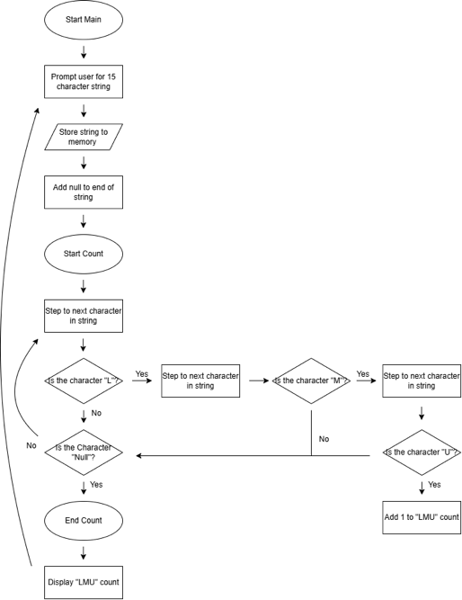

According to the flow chart, the first section of the program developed was to gather a user input of a string with 15 characters.

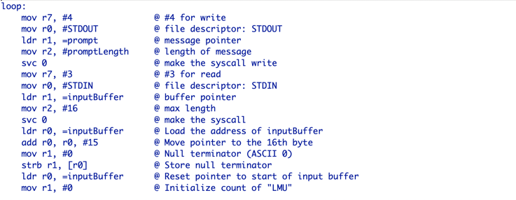

The function of this segment of the program is to prompt the user for the input, record the response, append a null character to the end of the input string, and load the location of the string in memory to register R0.

The next segment of the program was to process through the string checking for “LMU”

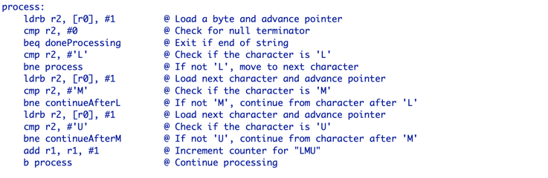

This function iterates through the string checking to find an “L”. When one is found, it will then look to see if the next letter is an “M”. It will repeat this process for a “U” if an “M” is also found. If “LMU” in its entirety is found, 1 will be added to register R1 which acts as the count. Once all characters of the input string have been processed, the algorithm progresses.

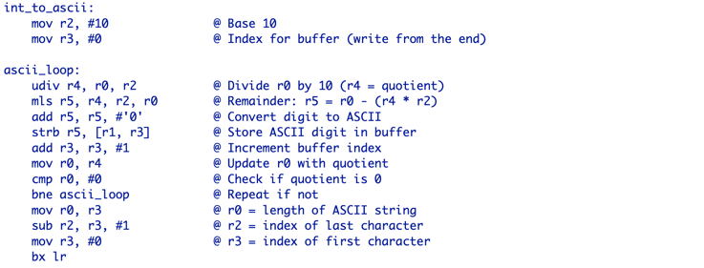

The function of this segment is to convert the integer value of the number of times “LMU” occurs to an ascii character so that it can be printed in the output.

The final segment of the program handles the message that is output to the user in the command window.

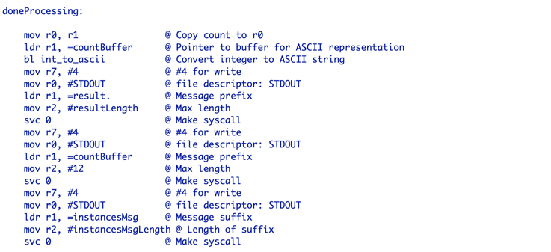

This function uses many of the same commands as the loop section as it focuses on writing prompts to the command window. It prints the output prompt in 3 different sections, the first half of the prompt, the occurrences of “LMU” in ascii, and the second half of the prompt. It displays as one cohesive sentence in the window.

Code for blinking the LEDs is included in the file but its correctness could not be tested as simulation tools were not available.

# III. Conclusion

The algorithm developed will be tested in the lab to ensure that it compiles and runs correctly on the Raspberry Pi 3b+. After being simulated using ARMsim# as seen in Figure 1 of appendix, the program currently works as intended.

# Appendix

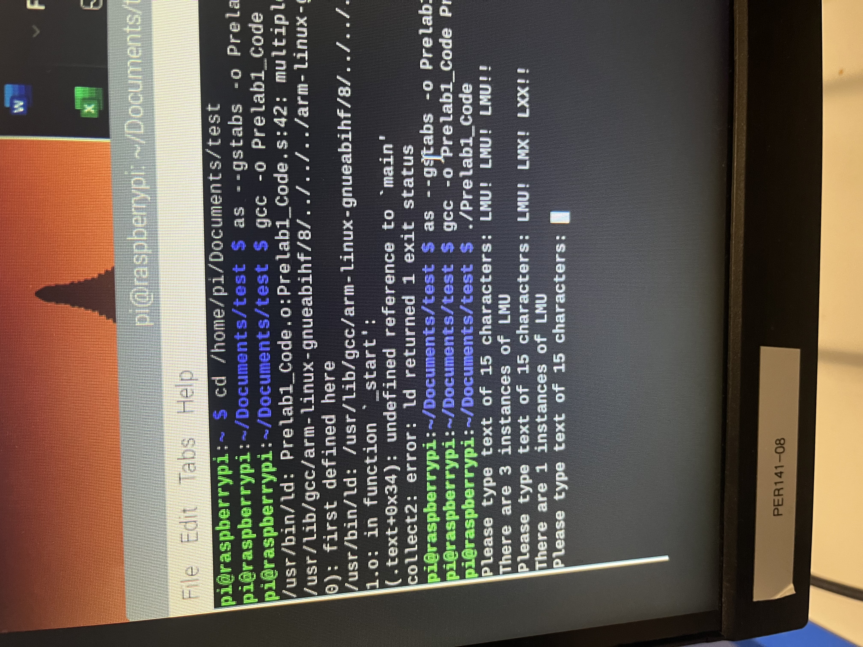

Figure 1: Simulation of Test Cases

References

[1] N. Ula, Introduction to ARM Assembly Language programming using Raspberry Pi, Loyola Marymount University, EECE3200-Lab01Tutorial.pdf, 2025

1.